Part A - PostgreSQL / SQL Assignment
TABLE REQUIRED COLUMNS
Departments

department_id INTEGER PRIMARY KEY, department_name VARCHAR(50), location VARCHAR(50)

employees

employee_id INTEGER PRIMARY KEY, employee_name VARCHAR(100), email
VARCHAR(100), salary DECIMAL, department_id INTEGER FOREIGN KEY, city
VARCHAR(50), joining_date DATE

CREATE DATABASE employee_management;

CREATE TABLE departments (
department_id INTEGER PRIMARY KEY,
department_name VARCHAR(50),
location VARCHAR(50)
);

Select *from Employees; // Check table created

CREATE TABLE employees (
employee_id INTEGER PRIMARY KEY,
employee_name VARCHAR(100),
email VARCHAR(100),
salary DECIMAL,
department_id INTEGER,
city VARCHAR(50),
joining_date DATE,
FOREIGN KEY (department_id)
REFERENCES departments(department_id)
);

Insert at least 5 departments and 10 employees, then write and execute these queries:
01 Create both tables and insert the required records.

INSERT INTO departments
(department_id, department_name, location)
VALUES
(1, 'IT', 'Mumbai'),
(2, 'HR', 'Pune'),
(3, 'Finance', 'Mumbai'),
(4, 'Sales', 'Delhi'),
(5, 'Testing', 'Pune')
(6,'Support','Banglore'),
(7,'sales','Gujarat');

INSERT INTO employees
(employee_id, employee_name, email, salary, department_id, city, joining_date, Phone_number)
VALUES
(1, 'Neha Verma', 'neha@gmail.com', 55000, 1, 'Mumbai', '2025-01-15', '9876541231'),
(2, 'Simran Singh', 'simran@gmail.com', 40000, 2, 'Gujarat', '2024-03-20', '1236547891'),
(3, 'Siddhant Kamble', 'siddhant@gmail.com', 55000, 1, 'Bangalore', '2025-02-10', '8757848754'),
(4, 'Nitin Pawar', 'nitin@gmail.com', 42000, 3, 'Pune', '2023-07-12', '1235647883'),
(5, 'Tanishq Verma', 'tanishq@gmail.com', 42000, 1, 'Delhi', '2025-04-01', '5647994561'),
(6, 'Neha Kumari', 'nehak@gmail.com', 28000, 2, 'Mumbai', '2024-08-18', '9865423654'),
(7, 'Rohan Mehta', 'rohan@gmail.com', 65000, 4, 'Pune', '2025-01-05', '5423698751'),
(8, 'Piyush Shah', 'piyush@gmail.com', 39000, 5, 'Mumbai', '2023-11-25', '5649875123'),
(9, 'Anil Roy', 'anil@gmail.com', 45000, 3, 'Delhi', '2025-06-15', '6653245896'),
(10, 'Nilima Rao', 'nilima@gmail.com', 52000, 5, 'Pune', '2024-12-10', '9865423651');

Select *from Employees; // check

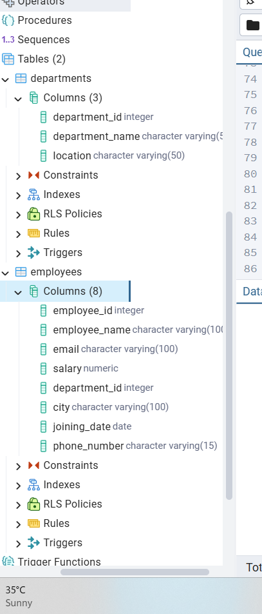
Task 3 -DQL / SELECT Queries

02 Display all employees; then display only employee names and salaries.

Select *from Employees; // check

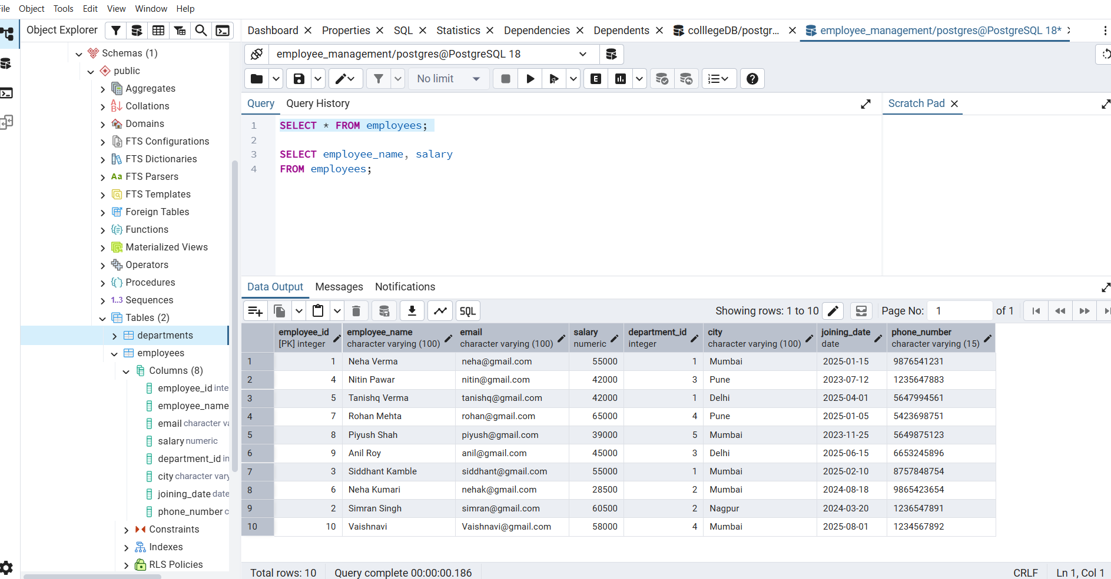

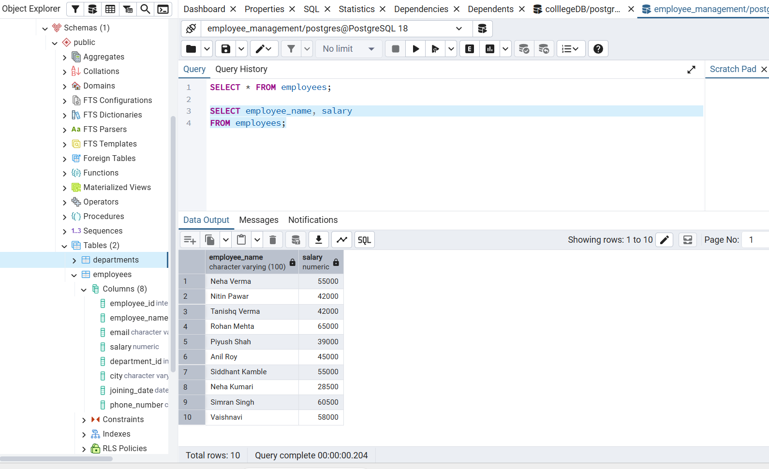

03 Find salaries above 50,000; employees in Mumbai
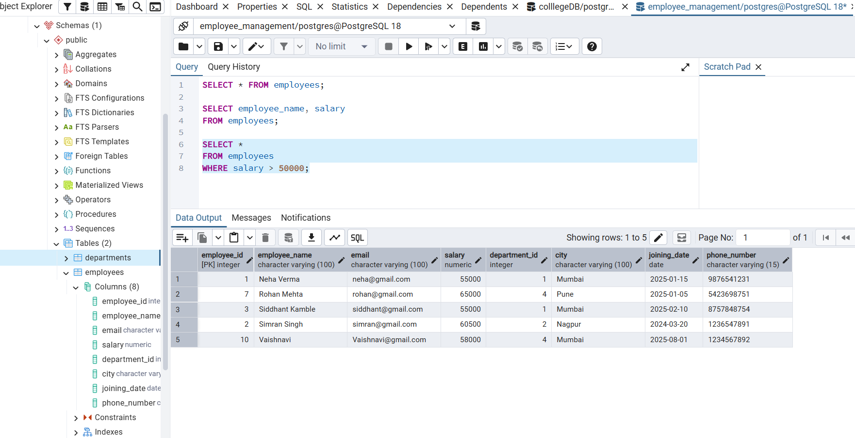

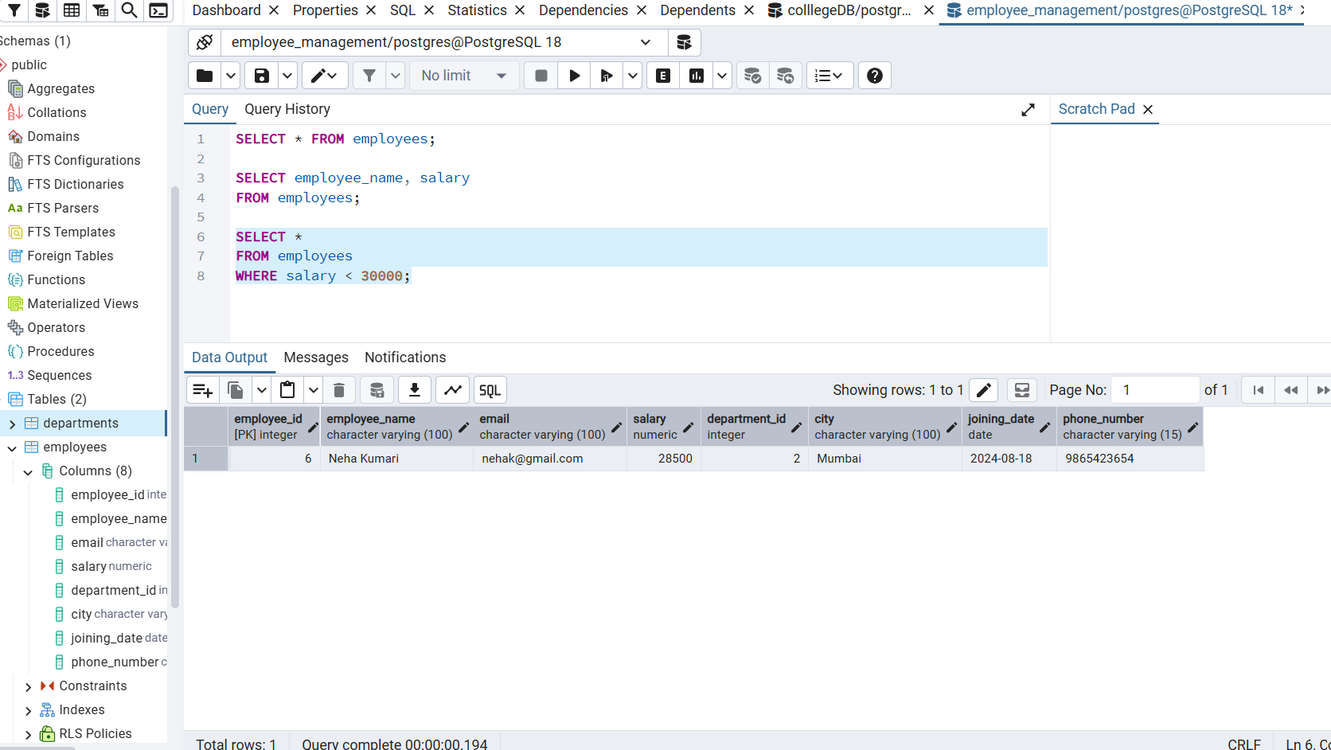
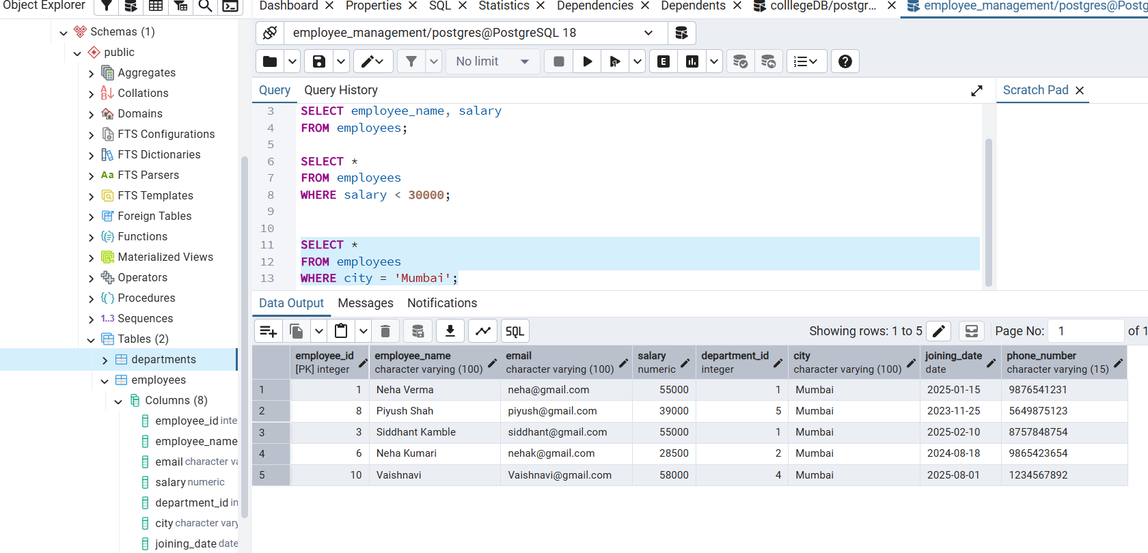

3.1 ) salaries between 30,000 and 70,000;
Employees in Mumbai or Pune.

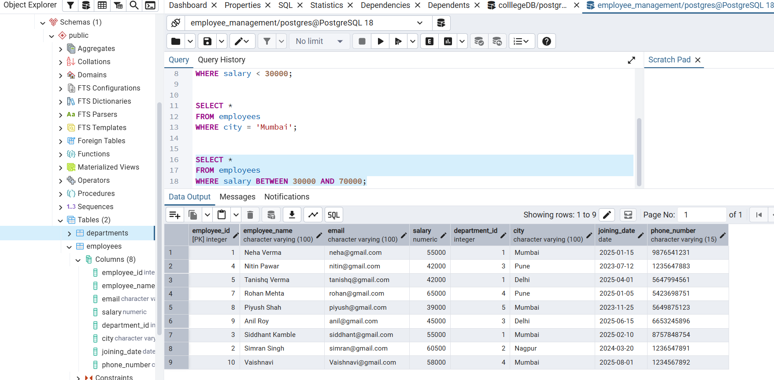
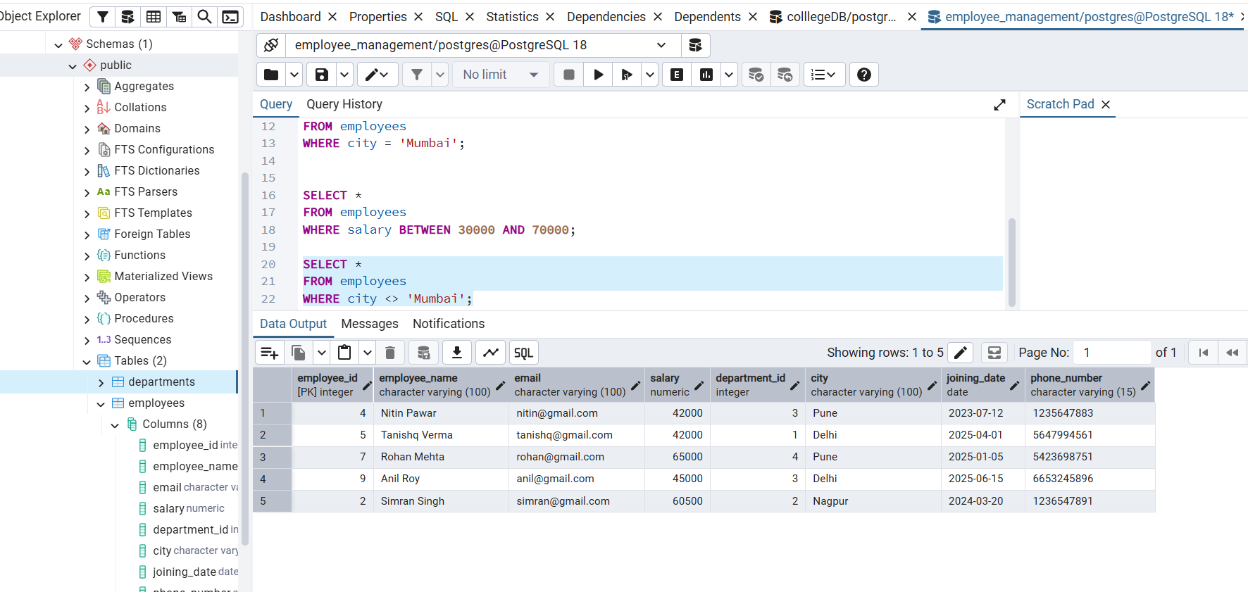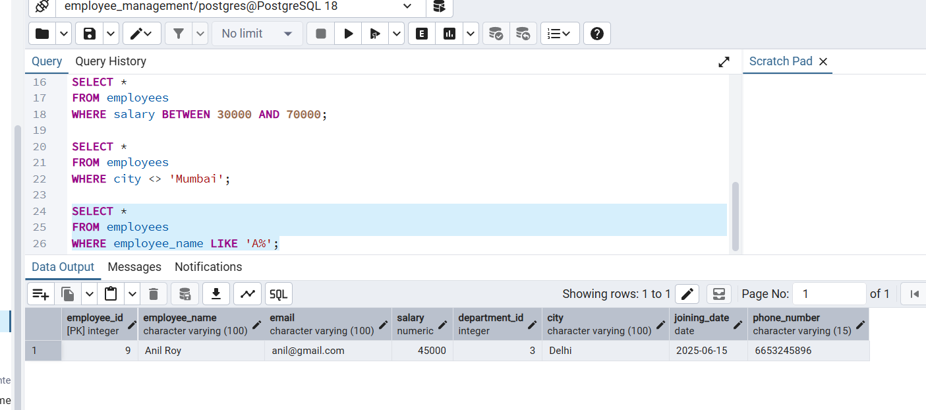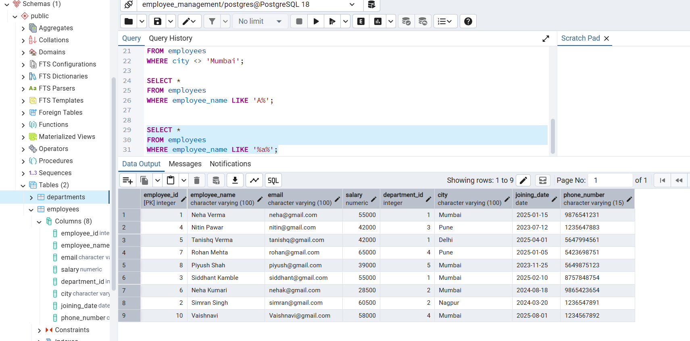

04 Display distinct cities; update one salary;
delete one employee;
sort employees by salary from
highest to lowest.

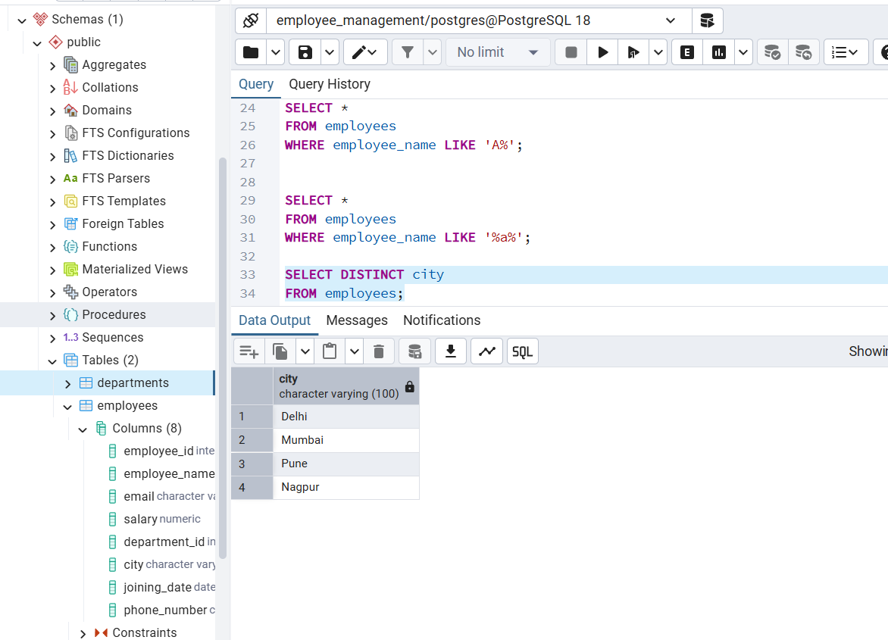

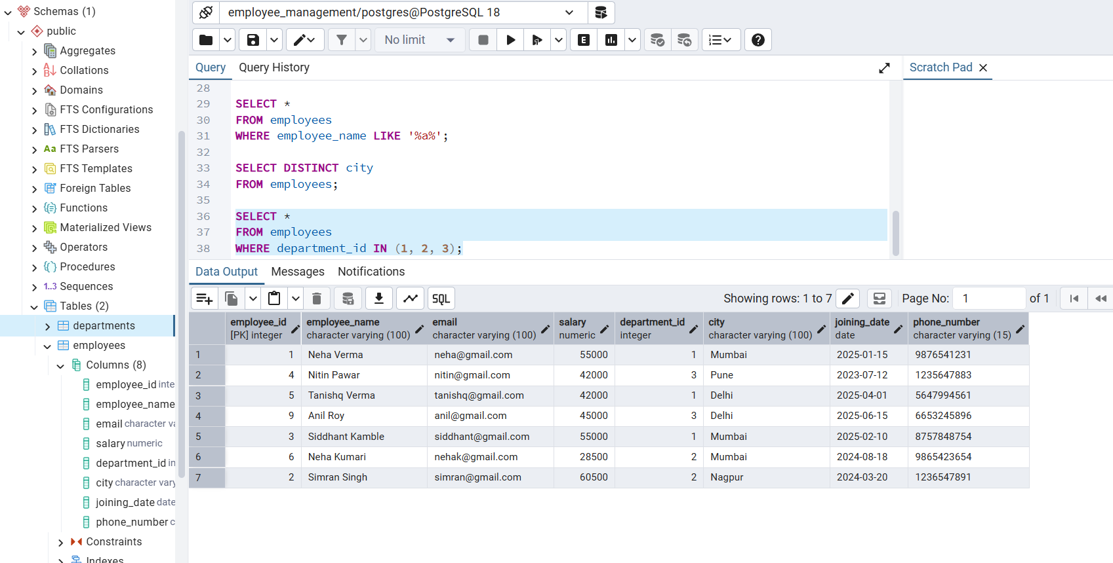

TASK 4- SQL Clauses

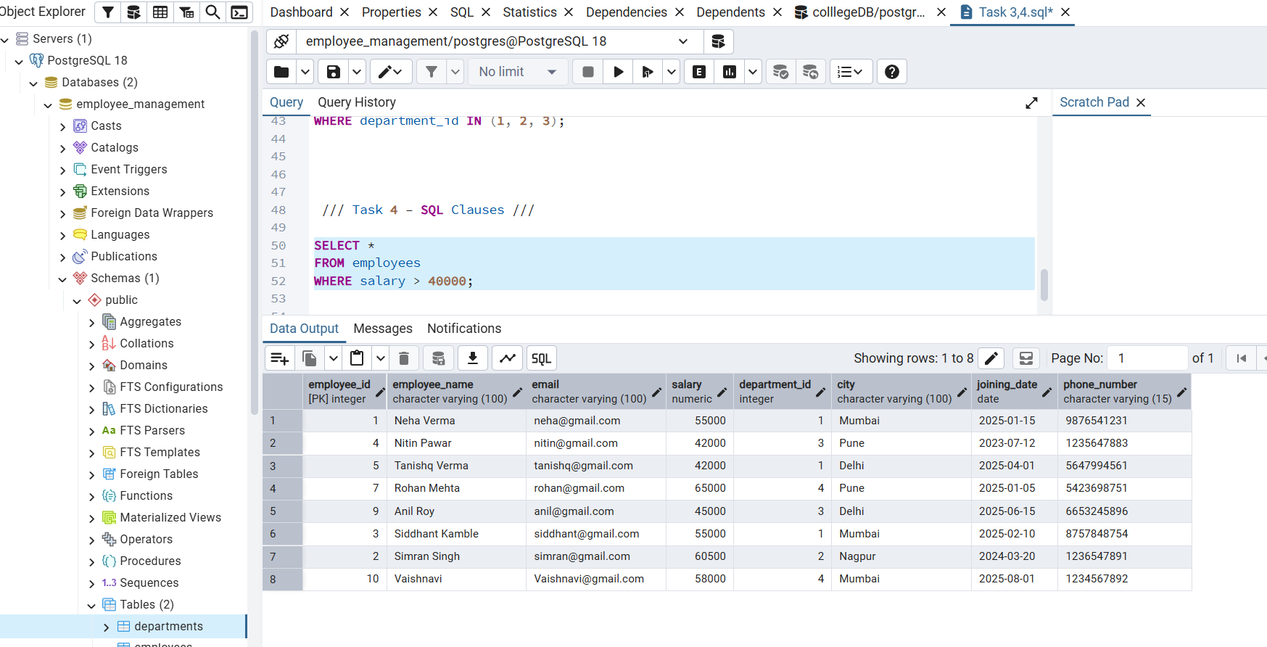

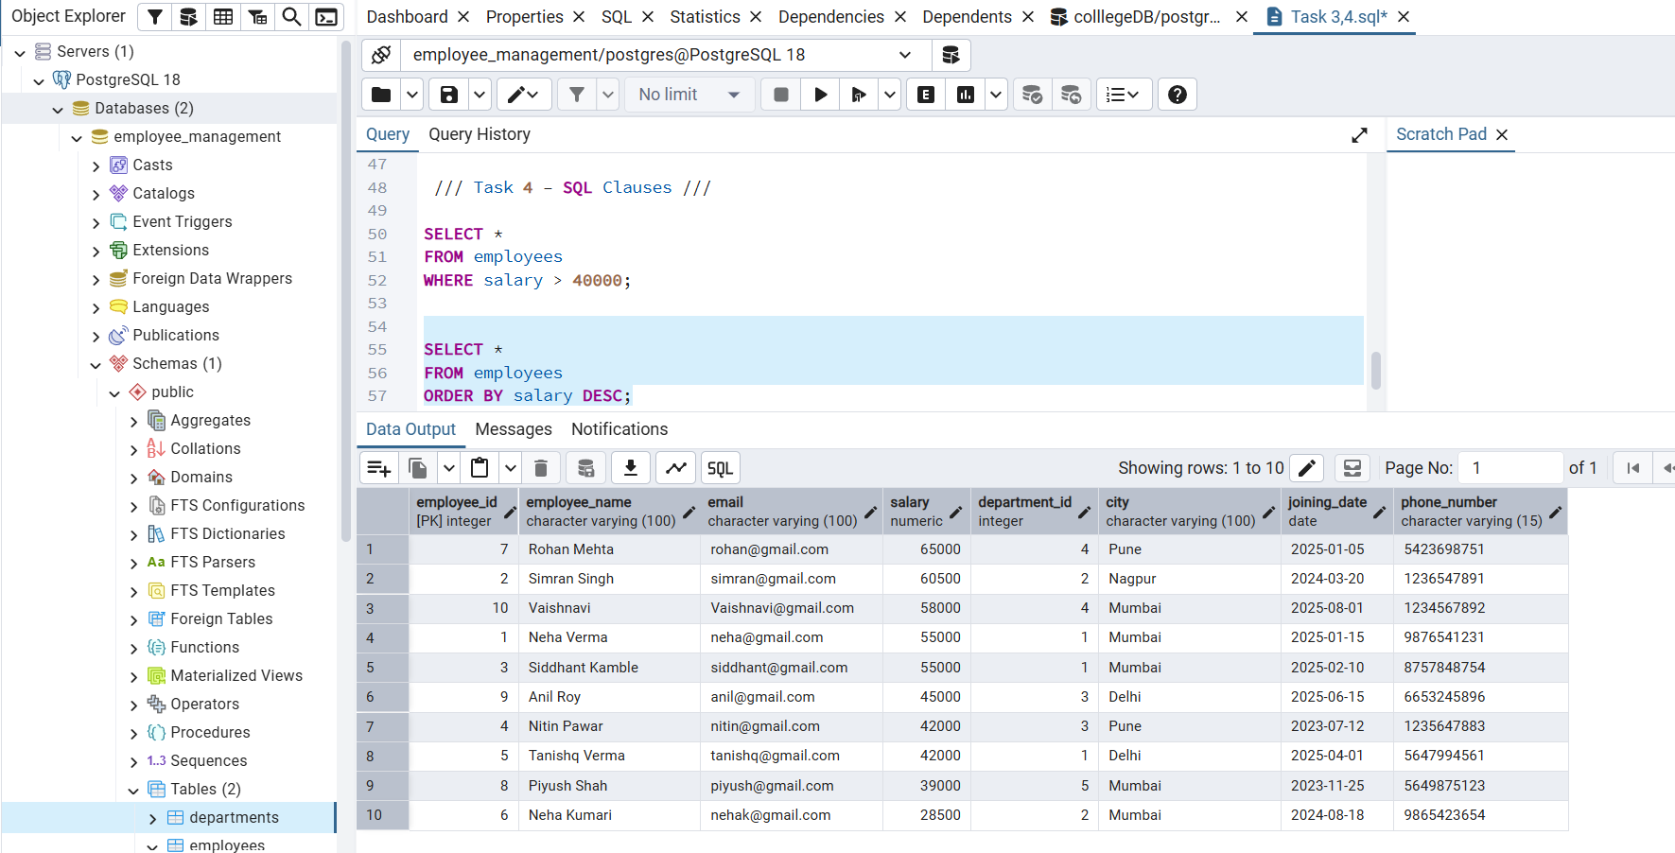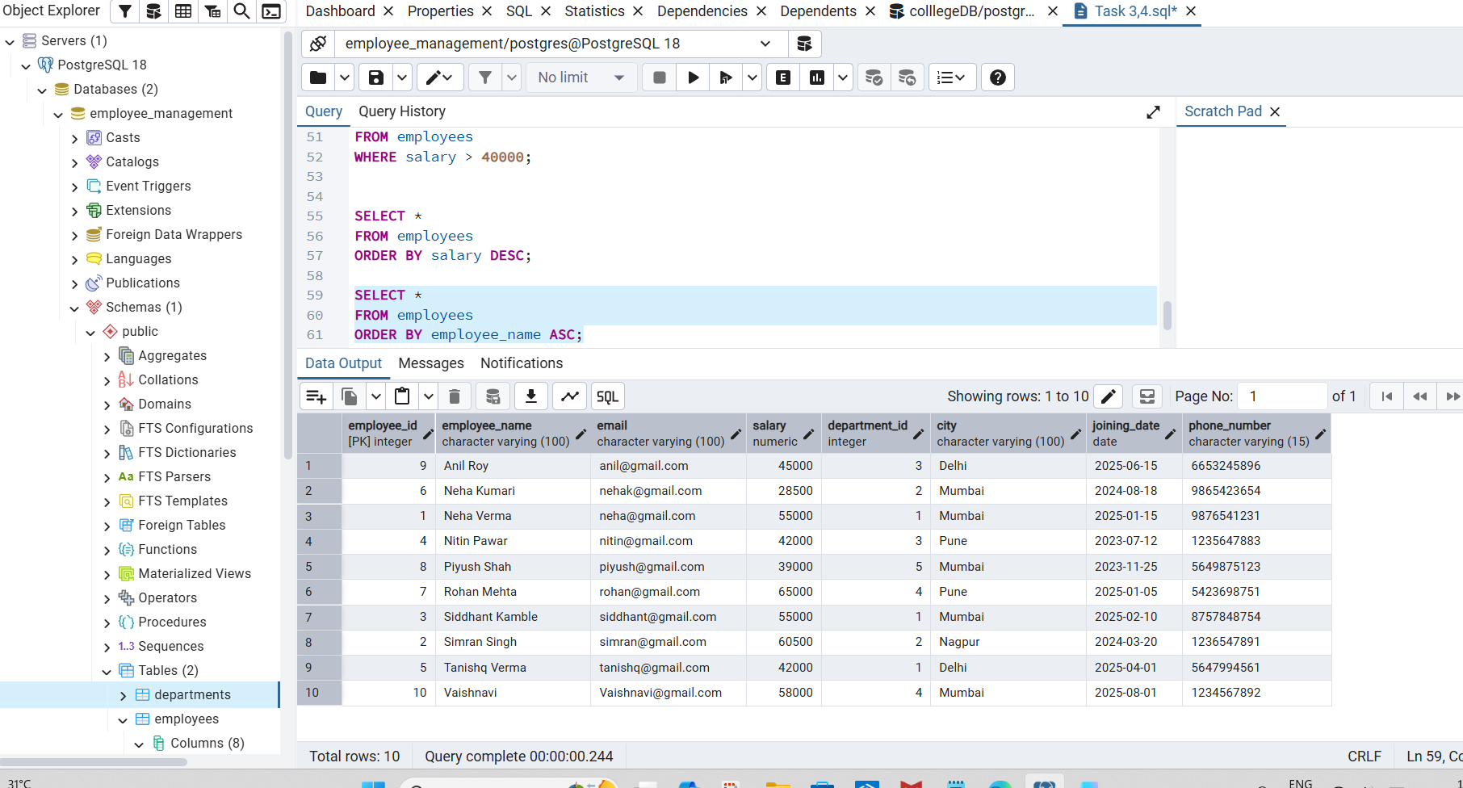

05 Count employees by department;
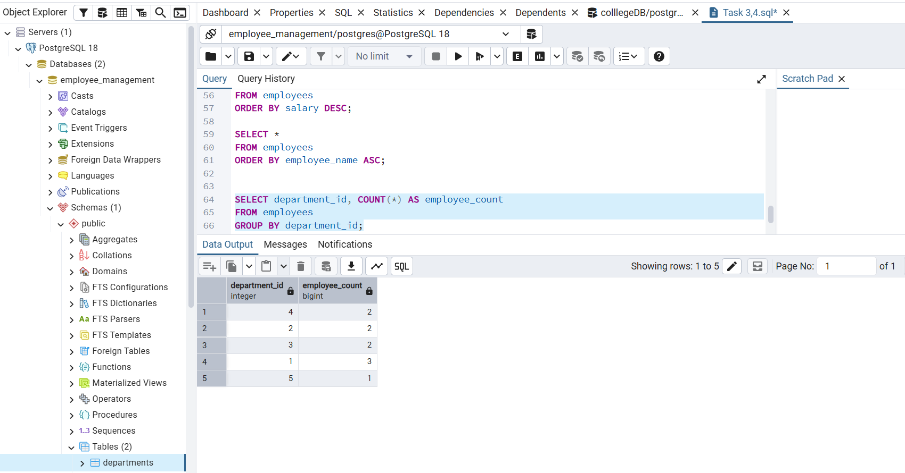
show departments having more than two employees.

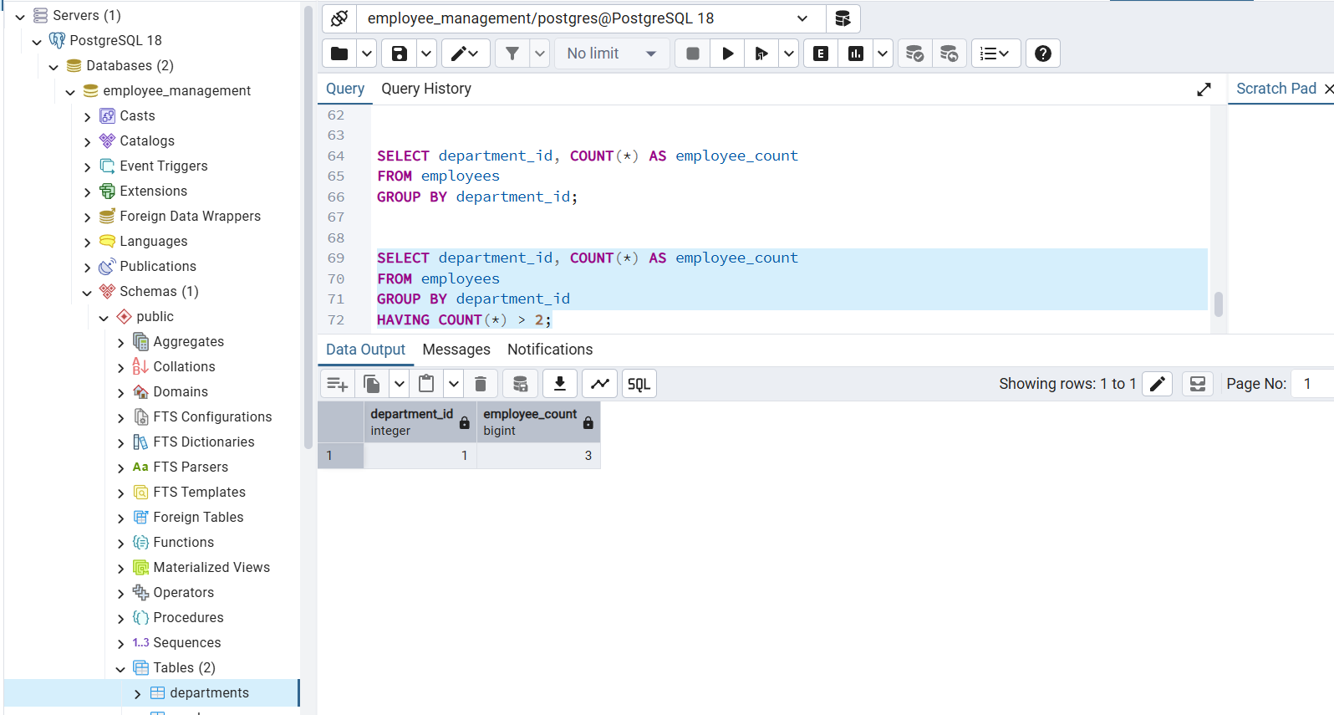
Task 5 – Aggregate Functions

06 Find the total, average, minimum and maximum salary.

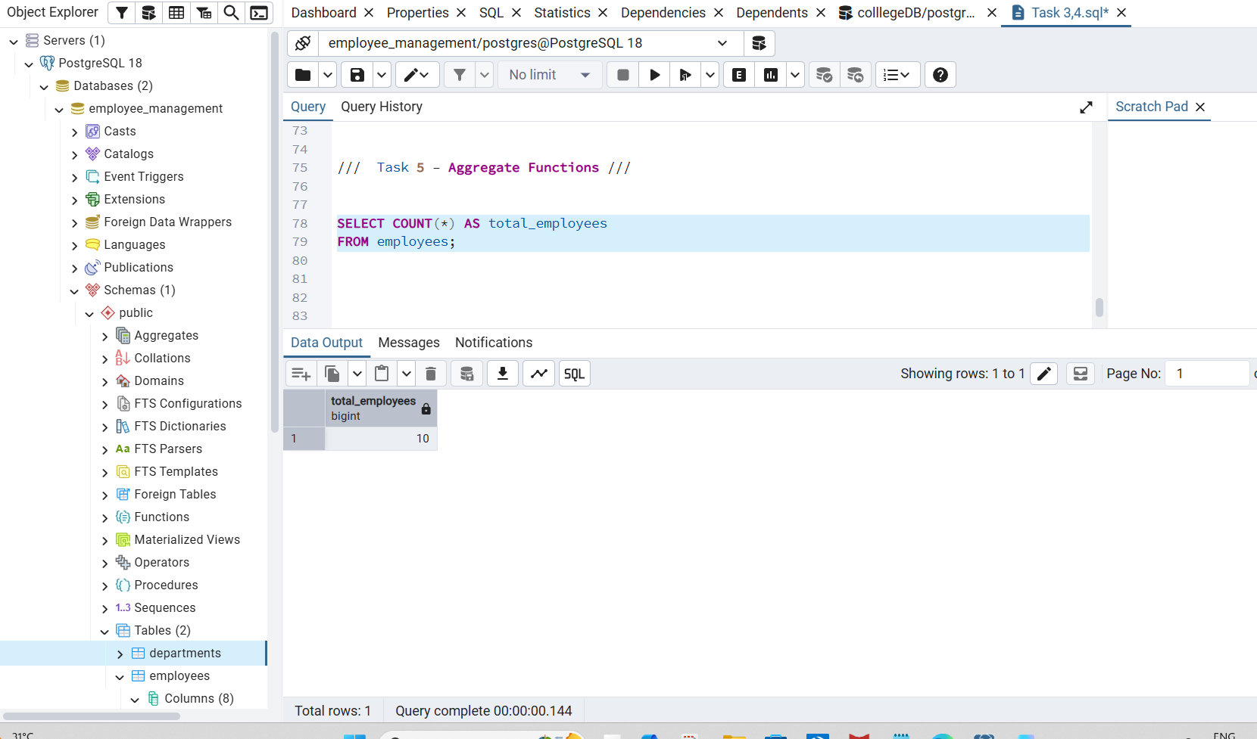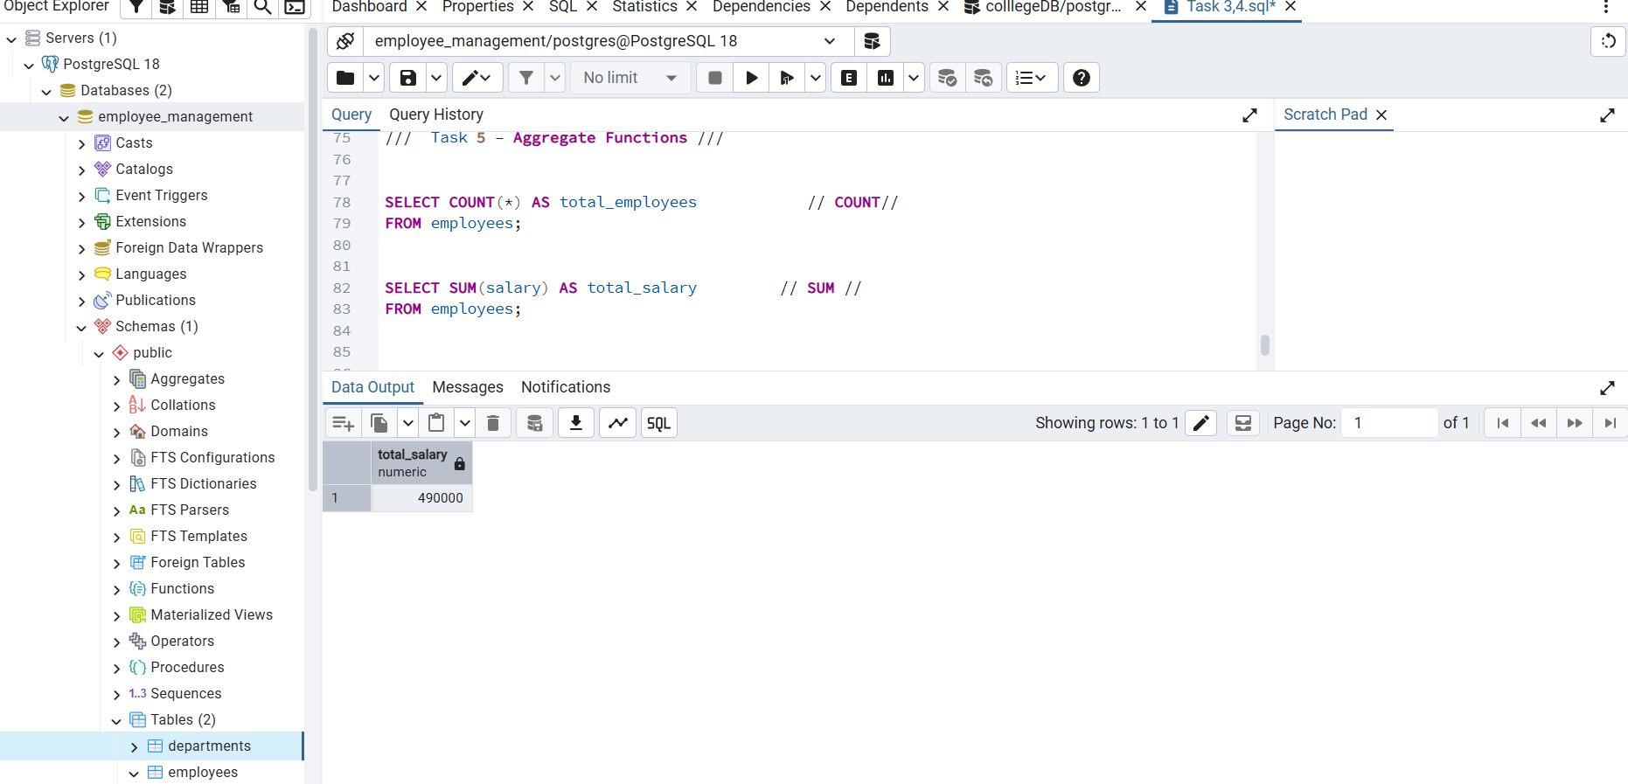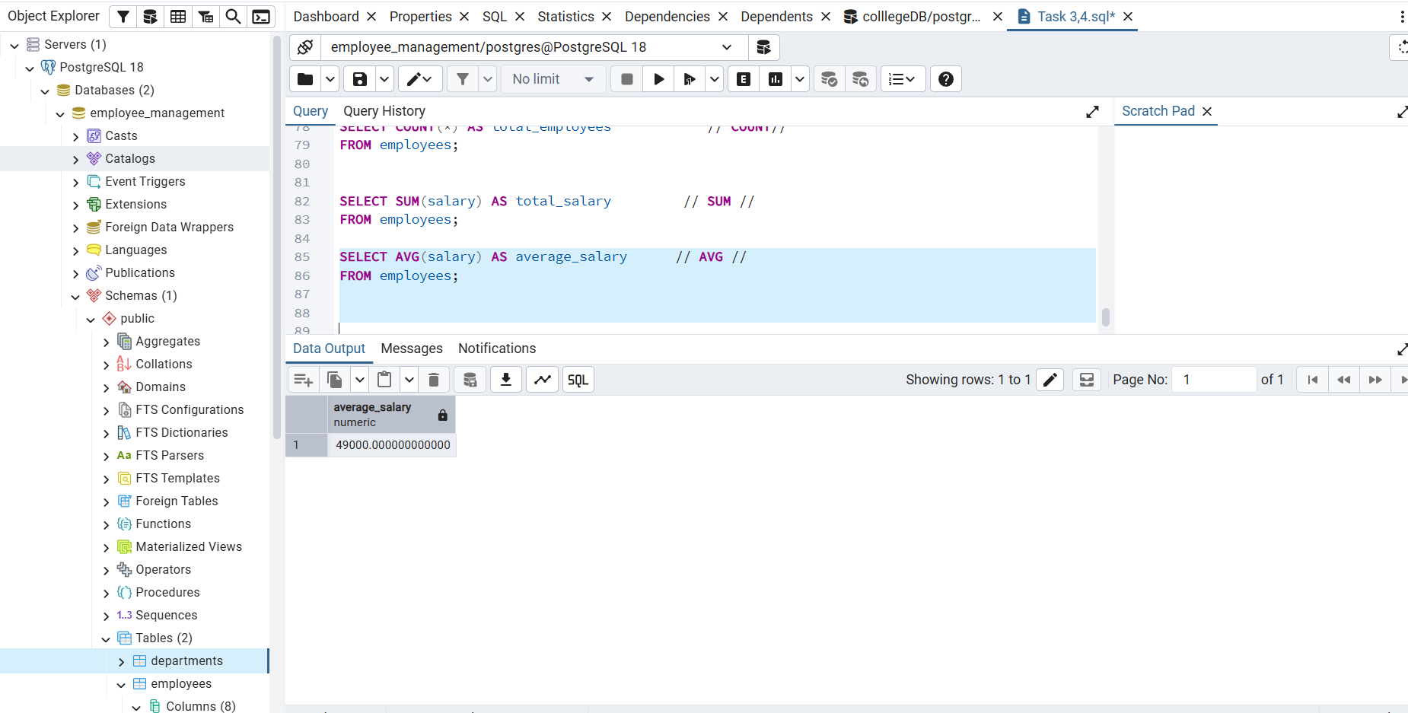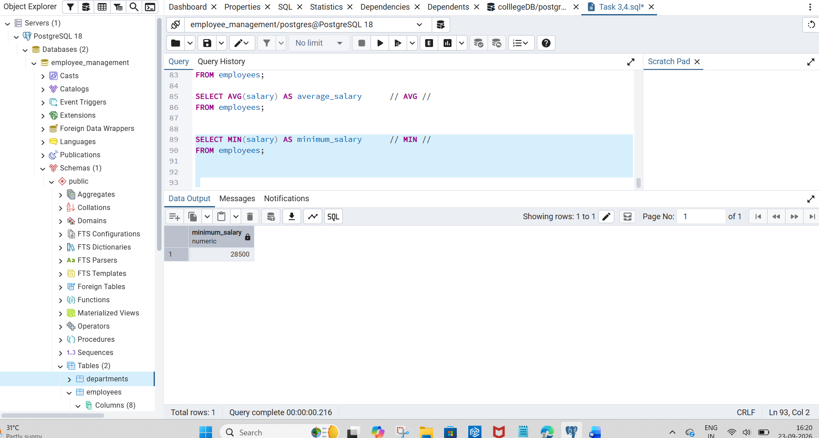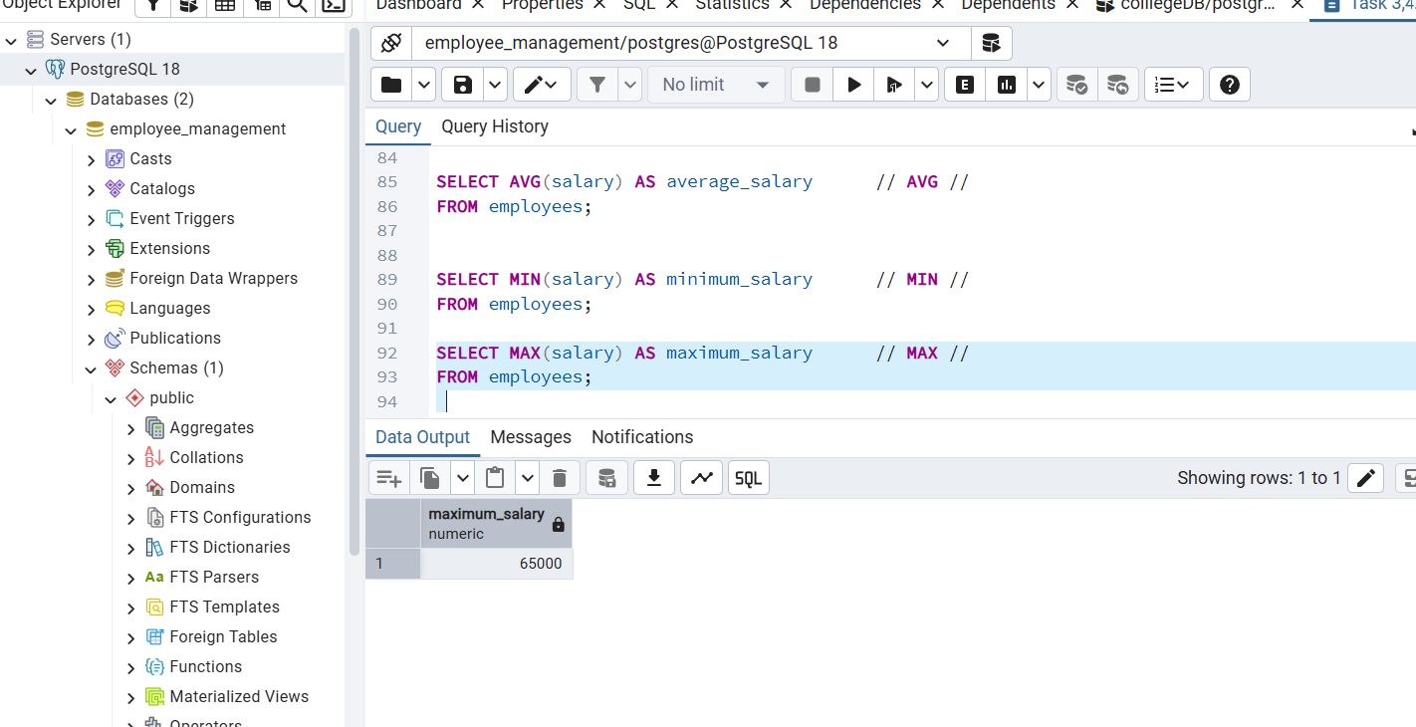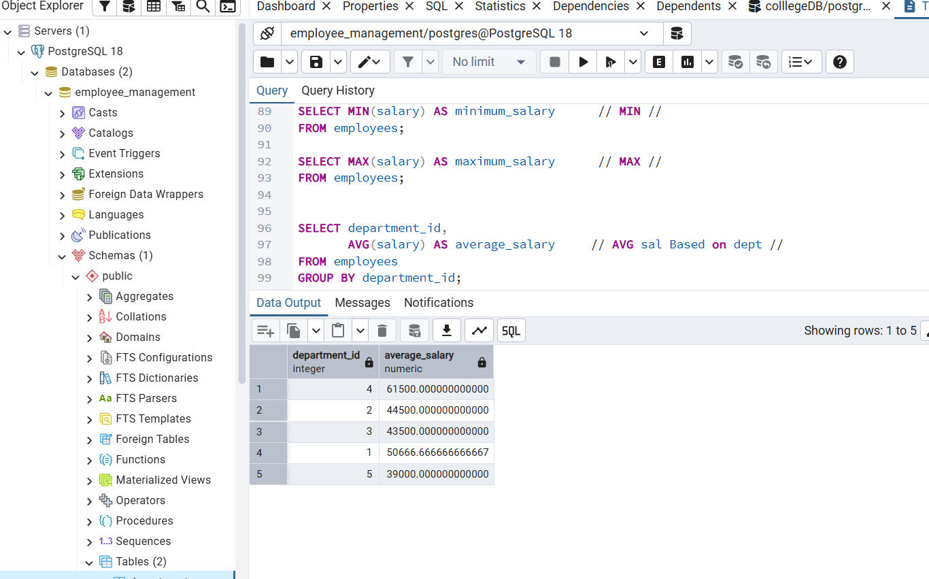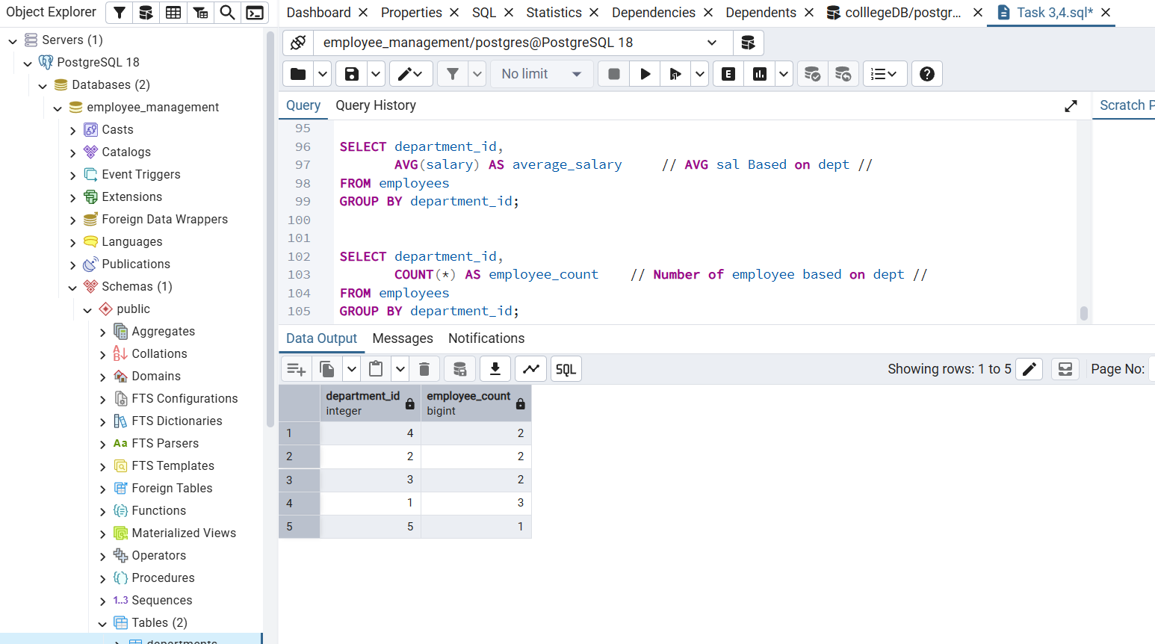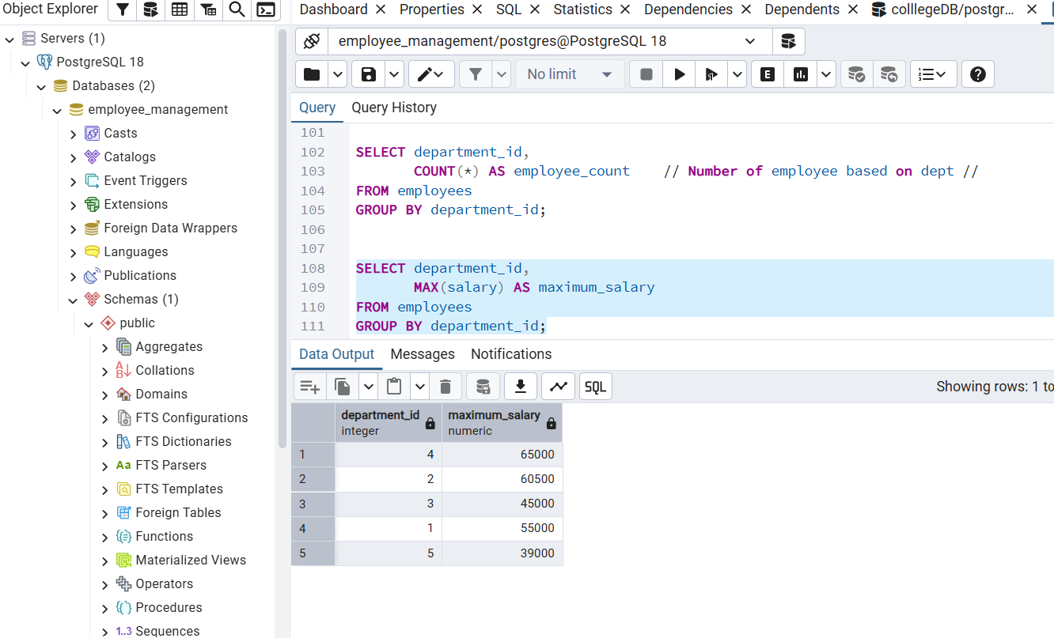

Task 6 – JOINs
INNER JOIN

07 Use INNER JOIN to show employee name, salary and department;
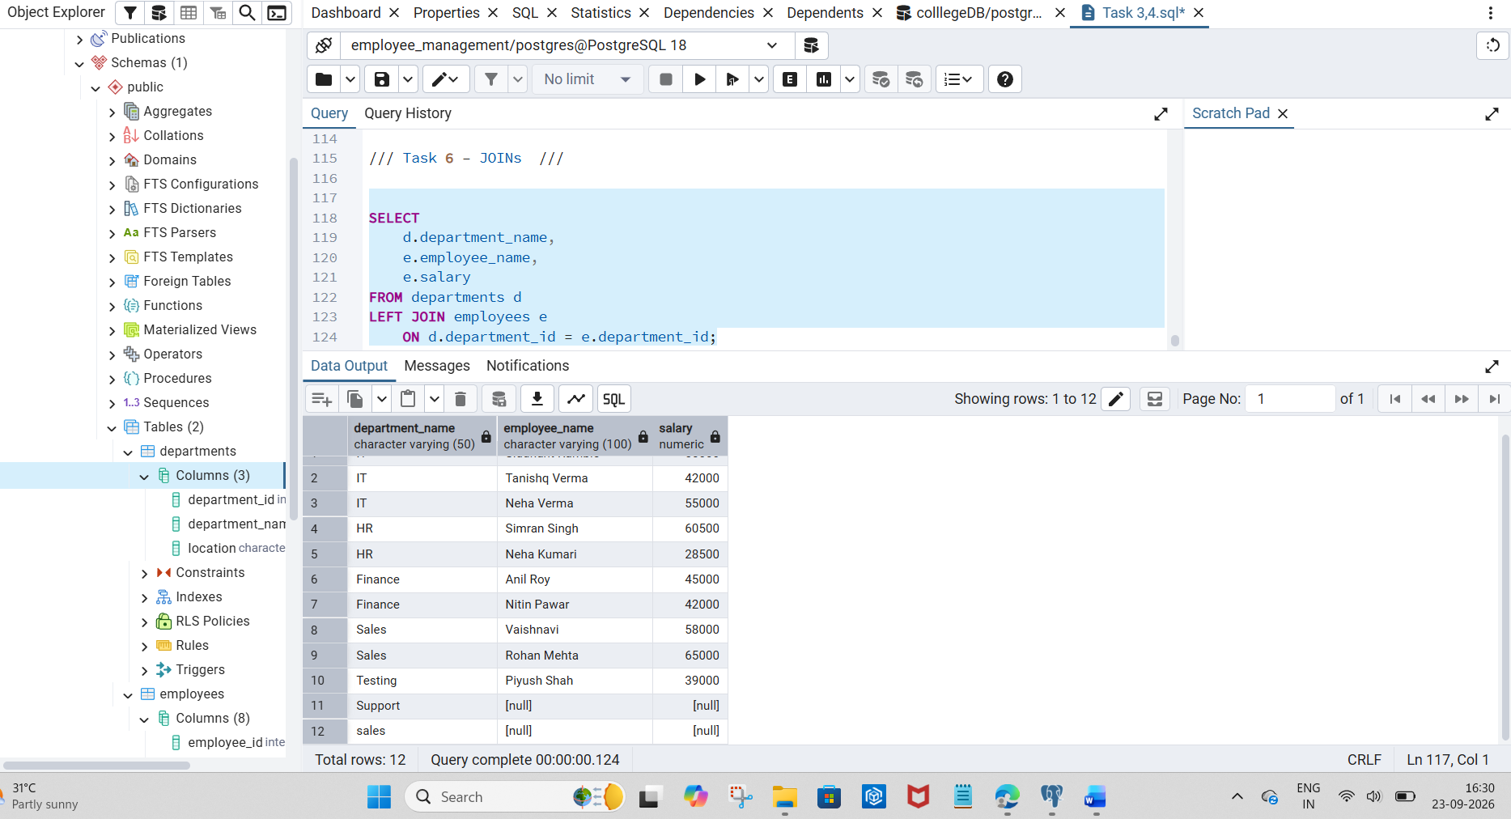
R- employee
L- department

use LEFT JOIN to show all
departments name and matching employees.

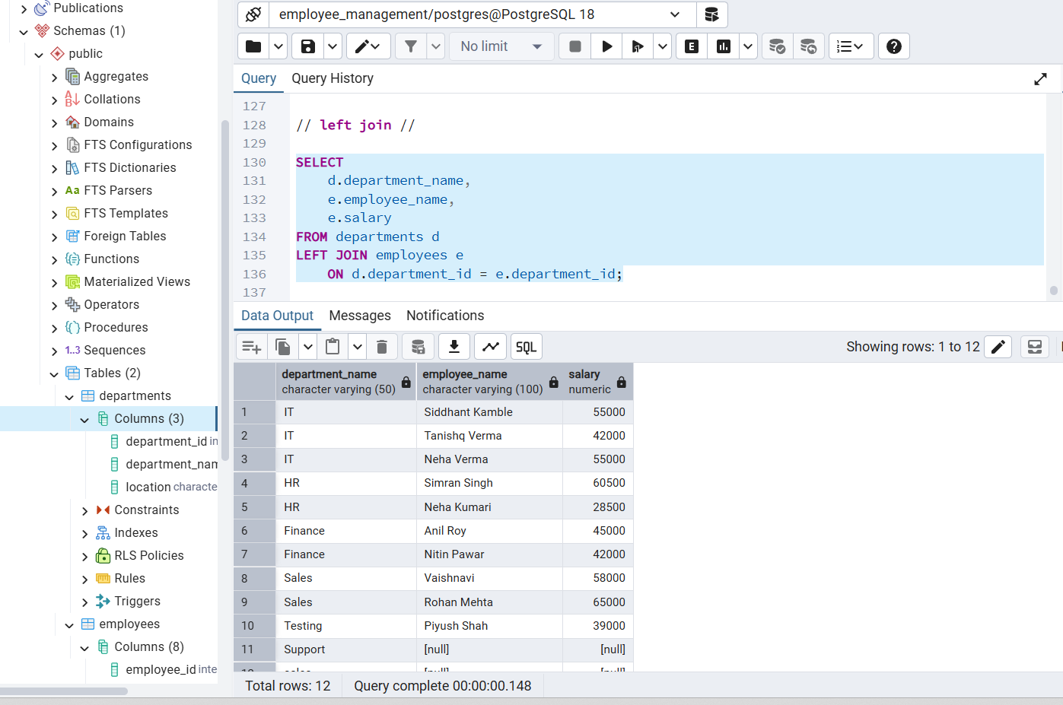

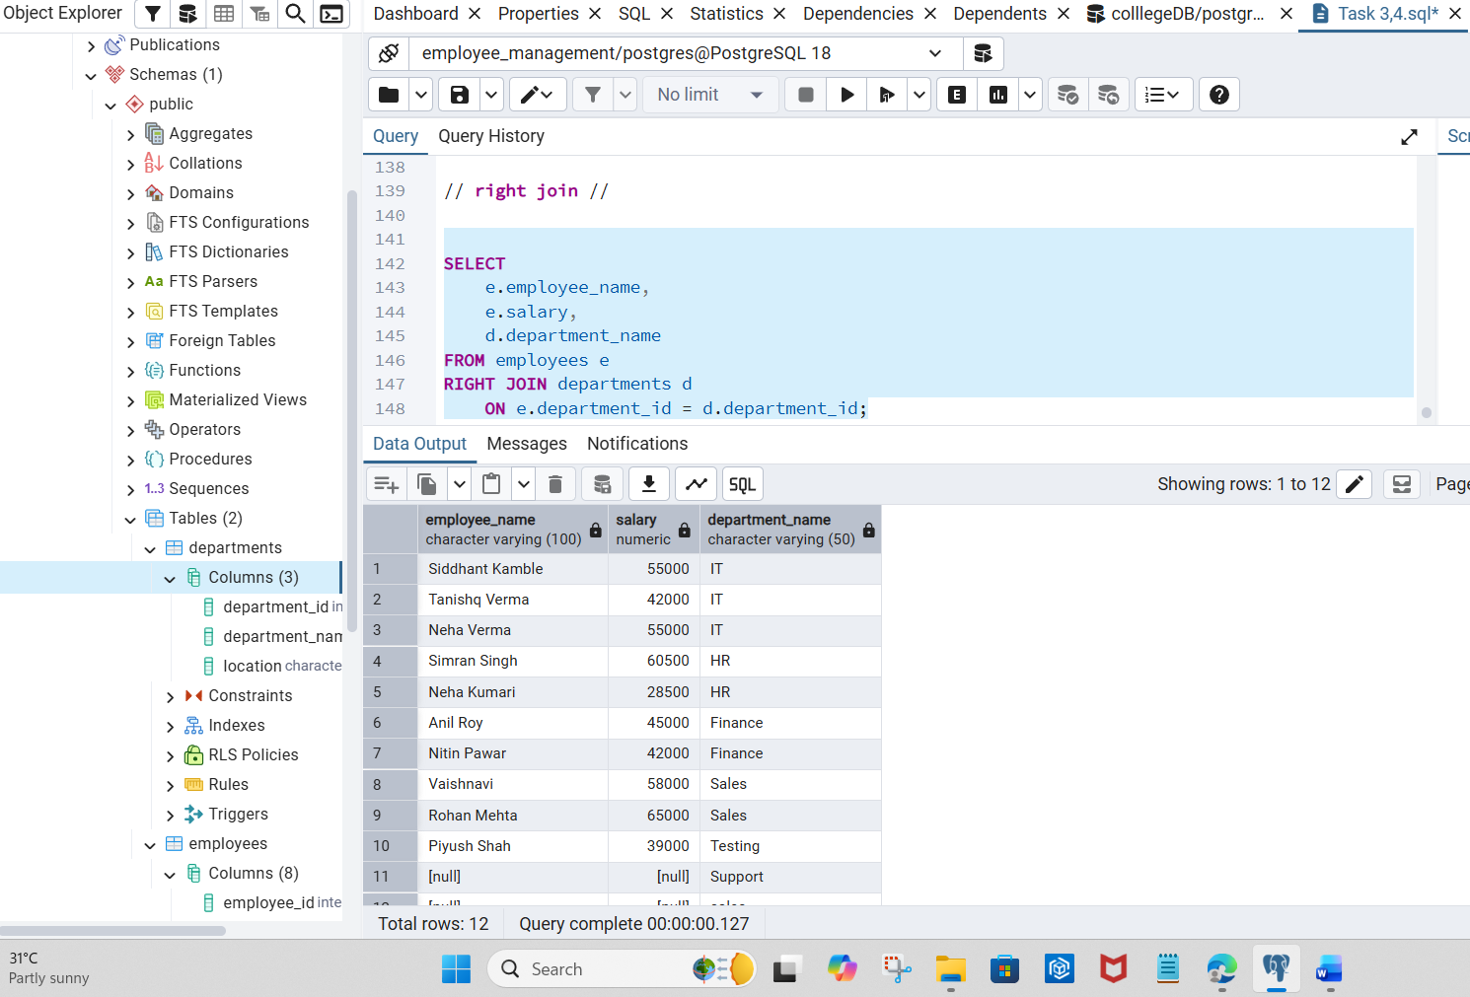
Task 7 - TCL Commands
Commit
08 Demonstrate COMMIT, ROLLBACK and SAVEPOINT using suitable statements.

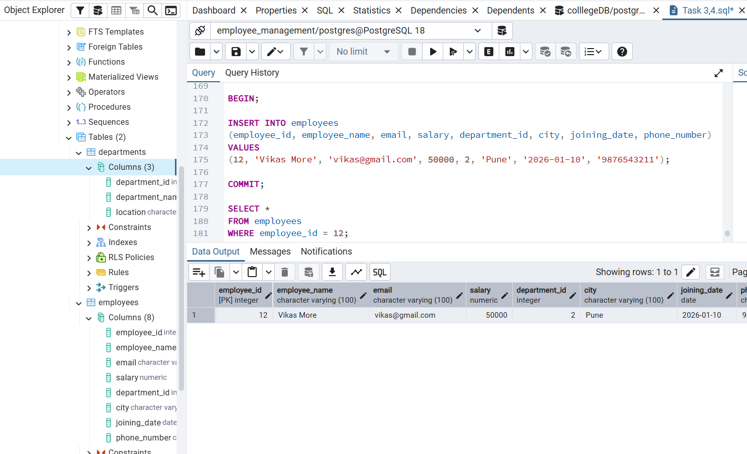

Rollback

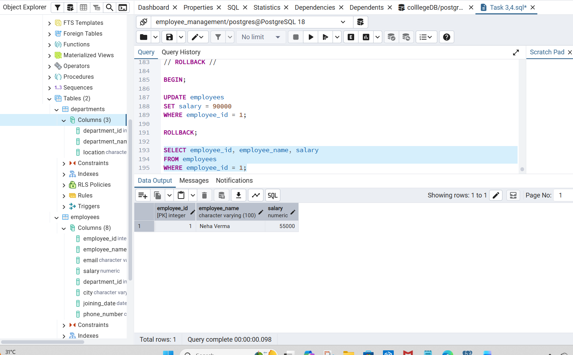

Save point

